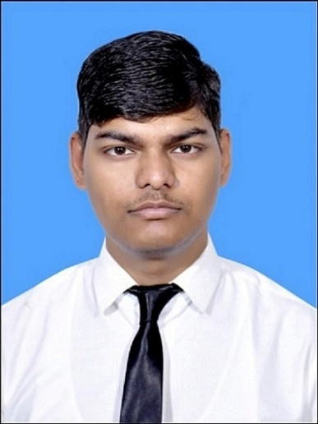

PULKIT GAUTAM
COMPUTER VISION ENGINEER

Work Experience

Project Engineer

IRDE, DRDO, Dehradun | September 2024 – Present
Working in Thermal Imaging Laboratory on Electro-Optical System Design, Integration and Testing.
- Developed real-time computer vision pipelines for MWIR thermal imaging systems, including AI-based target detection, multisensor image fusion, and digital image stabilization
- Designed and deployed GPU-based deep learning inference pipelines (Python) for real-time performance on edge platforms
- Implemented thermal image processing and enhancement techniques, including non-uniformity correction (NUC) and Bad Pixel Replacement (BPR)
- Built and optimized image processing modules for FPGA-based video pipelines (Verilog) for real-time thermal imaging systems
- Integrated multiple sensors (thermal, visible, LRF, GPS) and performed system-level calibration, validation, and testing of electro-optical systems under real-world conditions
- Developed sensor interfacing, communication protocols, and system interface documentation (EICD) for embedded electro-optical systems








TECHNICAL SKILLS
Computer Vision & AI: Deep Learning, Object Detection, Image Stabilization, Multisensor Fusion, Image Super Resolution
Frameworks: TensorFlow, PyTorch, OpenCV
Programming: Python, MATLAB
Hardware Acceleration: NVIDIA Jetson (GPU), FPGA (Verilog)
Tools: CUDA, Git
Domains: Thermal Imaging, Real-Time Systems, Edge AI

SUMMARY
Computer Vision Engineer with 2+ years of experience in real-time systems, thermal imaging, and GPU-accelerated AI deployment. Strong background in deep learning, multisensor fusion, and image processing with hands-on experience in deploying models on edge platforms (NVIDIA Jetson). Experience spans thermal target detection, image super resolution, image stabilization, and real-time video pipelines.
+91 9058618662
Dehradun, U.K.
pulkitgautam02@gmail.com
GitHub
Portfolio
LinkedIn

CERTIFICATIONS

The Joy of Computing using Python 2023
Course by Prof. Sudarshan Iyengar, IIT Ropar – NPTEL

An Introduction to Artificial Intelligence 2022
Course by Prof. Mausam, IIT Delhi – NPTEL

HTML, CSS, and JavaScript for Web Developers 2020
Course by Johns Hopkins University – Coursera

PUBLICATIONs

“Hardware Implementation of Fixed-Pattern Noise Removal Algorithm for a HD Infrared Detector”
International Conference on Electro-Optics and Photonics (EOP), Springer Nature, 2025

EDUCATION

B. Tech. in Electronics and Communication 7.54 CGPA

National Institute of Technology Patna | 2020 – 2024

PROJECTS

Deep-Learning Based Real-Time Target Detection in Thermal Imaging Systems
Implemented and benchmarked models like YOLO v7, RCNN and Faster R-CNN using TensorFlow/PyTorch real-time thermal detection on GPU based platform.

Design and Simulation of Approximate Parallel Prefix Adder with Carry-Skip in Vivado
Designed an approximate prefix adder in Verilog and analyzed accuracy vs delay vs hardware trade-offs

Object Detection and Counting of Objects by Shape and Colour using Blob Analysis in MATLAB
Implemented using Blob Analysis Algorithm, Segmentation and Contour Detection in MATLAB.

Intern

IRDE, DRDO, Dehradun | January 2024 – June 2024
Internship at Thermal Imaging Laboratory on “Real-Time Target Detection in Thermal Imaging Systems on GPU based Platform”
- Built and deployed a real-time thermal target detection pipeline on NVIDIA Jetson AGX Orin.
- Created and annotated thermal imaging datasets for model training and evaluation.
- Implemented and benchmarked models like YOLOv7, Faster R-CNN using TensorFlow/PyTorch, analyzing latency vs accuracy trade-offs for real-time thermal detection.

